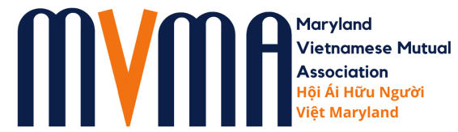
10770 Columbia Pike,
Suite 300-E17
Silver Spring, MD 20901

Tel. No.: (667) 225-1008
(301) 588-5868

2026 MVMA Scholarship Announcement

MVMA scholarships were designed to help ambitious and hardworking Vietnamese American students who lack the financial resources to achieve their educational goals. Many individuals, organizations, and businesses have contributed generously to this worthy cause. Two (2) $1,000 scholarships will be awarded to two (2) outstanding students this year.

Qualifications

Any Vietnamese American graduating from high school and residing in Maryland, who is enrolled as a first-year student at a university, college, or vocational school in the Fall of 2026 may apply to the MVMA College Scholarship Program. The Scholarship recipients will be required to participate in at least one MVMA community activity or outreach event in the upcoming academic year.

Submission Requirements & Deadline

Interested students are urged to submit their COMPLETE Scholarship Application Package no later than 5:00 pm on Monday, May 11, 2026. An original, signed application along with the COMPLETED checklist for the required supporting documentation (i.e., official transcript, personal essay, and letters of recommendation) must be received by the due date. Scholarship winners will be notified by telephone and/or email by Monday, May 26, 2026, and the award ceremony will be held at MVMA’s Annual Academic Awards Picnic to be held on Sunday June 7, 2026 (10am – 1pm) at Bohrer Park (Hillside Pavilion) in Gaithersburg, MD.

Application packages may be mailed, or emailed, to the following addresses:

Maryland Vietnamese Mutual Association, Inc. (MVMA)
- Columbia Pike, Suite 300-E17 Silver Spring, MD 20901
ATTN: Scholarship Committee

Email: hoan.dang@mdvietmutual.org and robert.riley@mdvietmutual.org

Education is not preparation for life; education is life itself. – John Dewey

